CS 542 Class Challenge

Report

Image Classification of COVID-19 X-rays

Student:

Harkirat Kaur Modi

Teacher:

Sarah Adel Bargal

Course:

CS 542 – Machine Learning

Contents

Introduction 3

Task 1 Binary Classification 3

Deep Neural Network Architecture Used 3

Optimizer, Loss Function, Parameters and Regularization 4

Accuracy and Loss 4

t-SNE Visualizations 4

Task 2 Multi-Class Classification 5

Deep Neural Network Architecture Used 5

Optimizer, Loss Function, Parameters and Regularization 5

Accuracy and Loss 6

ResNet50 vs. VGG16 6

t-SNE Visualizations 8

Conclusion 8

# Introduction

In this project we will classify X-ray images. The data we use has been collected by Adrian Xu, combining the Kaggle Chest X-ray dataset with the COVID-19 Chest X-ray dataset collected by Dr. Joseph Paul Cohen of the University of Montreal.

For Task 1, we trained a deep neural network model to classify normal vs. COVID-19 X-rays using the data we collected above.

For Task 2, we trained a deep neural network model to classify an X-ray image into one of the following classes: normal, COVID-19, Pneumonia-Bacterial and Pneumonia-Viral using the data we collected above.

# Task 1 Binary Classification

## Deep Neural Network Architecture Used

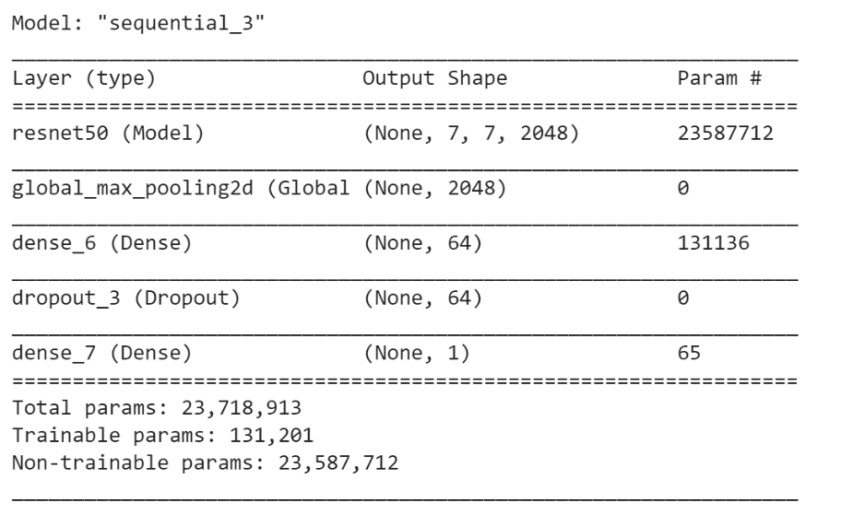In this task we trained a deep neural network to classify normal vs. COVID-19 X-rays using the data we collected. Here I started with training a ResNet50 architecture using pre-trained weights from ‘imagenet’. ResNet50 architecture was chosen over other models as it has skip connections between layers that add the output from previous layers to the output of stacked layers which helps us train deeper networks. We then add a Global Max Pooling 2D layer to extract the most important features and then add a Dense layer with 64 neurons and ReLu activation to introduce non-linearity in the model. We next add a dropout layer with a rate of 0.5 to avoid overfitting and lastly add another dense layer with one neuron and the sigmoid activation function as we are conducting a binary classification.

## Optimizer, Loss Function, Parameters and Regularization

The optimizer used in this model is the Adam algorithm with a learning rate of 0.001 as it is computationally efficient and requires little memory space. Binary Cross Entropy loss function is used as we are attempting to conduct a binary classification between Normal vs. COVID-19 Chest X-Rays. The regularization techniques used are Data Augmentation by horizontally flipping images and Dropout Layer. The goal of using regularization to the prevent overfitting

## Accuracy and Loss

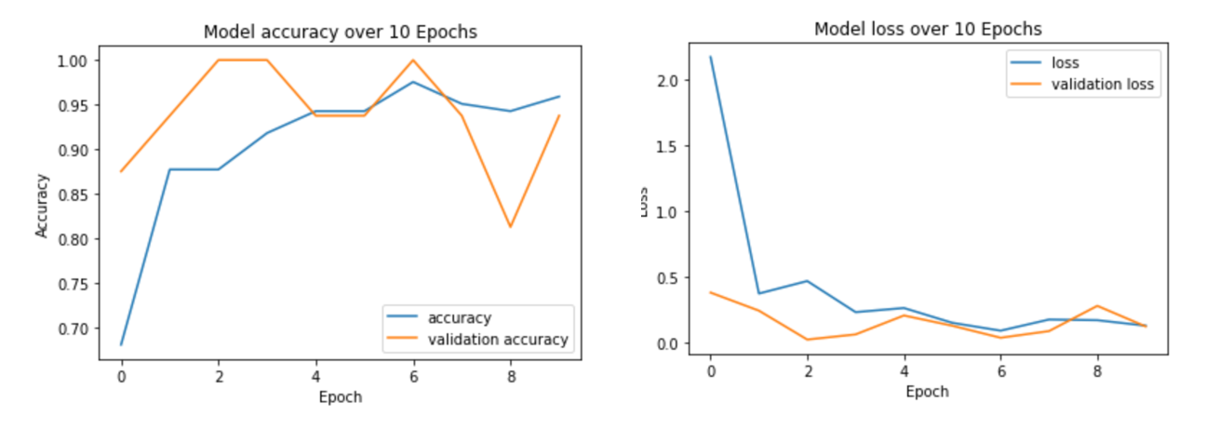In the accuracy plot for the model we can see that the validation accuracy is higher than the training accuracy. In the loss plot for the model we can see that with each new iterating validation loss ≈ training loss which shows that the model is converging in very few epochs. We can conclude from both accuracy and loss graphs that the model is not overfitting.

## t-SNE Visualizations

As we can see in the graph below that the t-SNE 2-D Visualization for the two classes, Normal and COVID-19 Chest X-rays. The extracted features are good as the data points representing the two classes appear in their two distinct clusters.

# Task 2 Multi-Class Classification

## Deep Neural Network Architecture Used

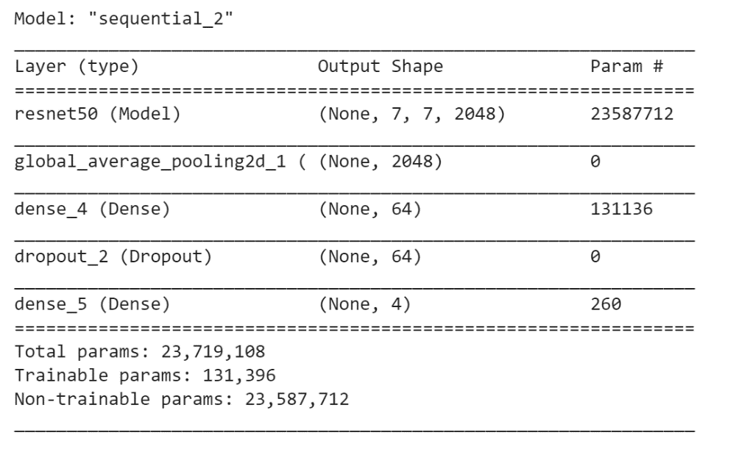In this task we trained a deep neural network to classify an X-ray image into one of the following classes: normal, COVID-19, Pneumonia-Bacterial and Pneumonia – Viral using the data mentioned above. Here I started with training a ResNet50 architecture using pre-trained weights from ‘imagenet’. ResNet50 architecture was chosen over other models as it has skip connections between layers that add the output from previous layers to the output of stacked layers which helps us train deeper networks. We add a Global Average Pooling 2D layer to the model to calculate the average output of each feature map in the previous layer that helps us reduce data and also reduces the tendency of overfitting. Next, we add a Dense layer with 64 neurons and ReLu activation to introduce non-linearity in the model. We next add a dropout layer with a rate of 0.5 to avoid overfitting and lastly add another dense layer with four neurons (equal to the number of classes) and the softmax activation function as we are conducting a multi-class classification.

## Optimizer, Loss Function, Parameters and Regularization

The optimizer used in this model is the Adam algorithm with a learning rate of 0.001 as it is computationally efficient and requires little memory space. The batch-size was reduced from 10 to 8 as the GPU ran out of memory. Categorical Cross Entropy loss function is used as we are attempting to conduct a multi-class classification to classify a Chest X-ray image into one of the following classes: normal, COVID-19, Pneumonia-Bacterial and Pneumonia – Viral. The regularization techniques used are Data Augmentation by horizontally flipping images, Dropout and Global Average Pooling layer. The goal of using regularization is to the prevent overfitting

## Accuracy and Loss

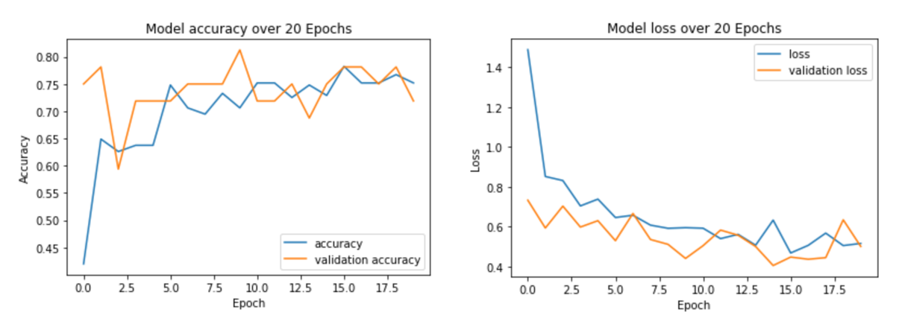In the accuracy plot for the model we can see that the validation accuracy is higher than the training accuracy. In the loss plot for the model we can see that with each new iterating validation loss ≈ training loss which shows that the model is converging in very few epochs. We can conclude from both accuracy and loss graphs that there is no overfitting.

## ResNet50 vs. VGG16

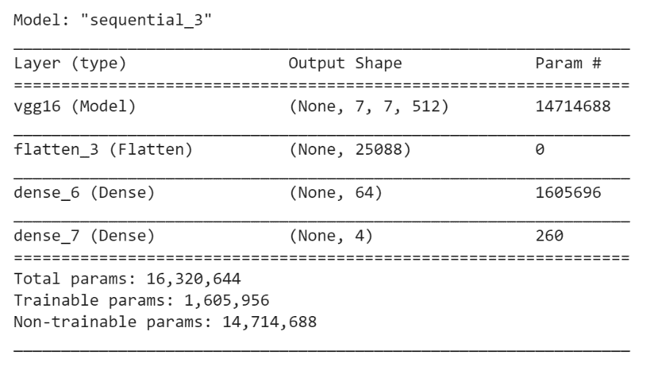We compared the performance of the ResNet50 architecture described above to VGG16 architecture. We created a new model with VGG16 architecture with pre-trained weights from imagenet. We started by adding a Flatten Layer to flatten the input. Next, we added a Dense layer with 64 neurons and ReLu activation function to introduce non-linearity. Lastly, we added another Dense layer with four neurons (equal to the number of classes) and Softmax activation function as we are conducting a multi-class classification.

The optimizer used in this model is the Adam algorithm with a learning rate of 0.001 as it is computationally efficient and requires little memory space. The batch-size was reduced from 10 to 8 as the GPU ran out of memory. Categorical Cross Entropy loss function is used as we are attempting to conduct a multi-class classification to classify a Chest X-ray image into one of the following classes: normal, COVID-19, Pneumonia-Bacterial and Pneumonia – Viral. The regularization technique used is Data Augmentation by horizontally flipping images to prevent overfitting.

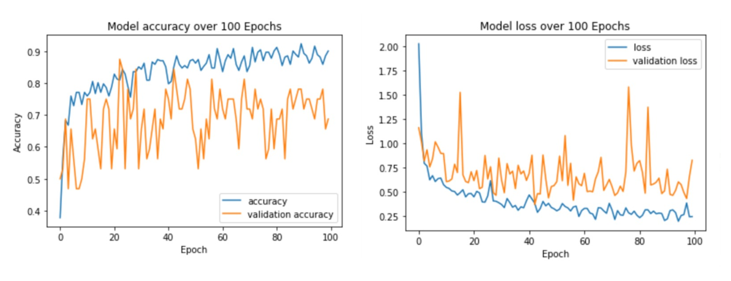The accuracy and loss graphs below show that the model is not converging and there is slight overfitting.

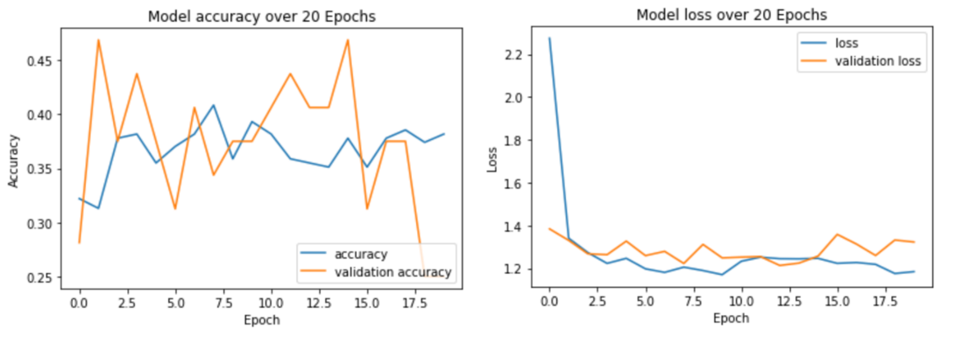Adding a Dropout layer for regularization did not help and in turn reduced accuracy as can be seen in the graphs below.

Hence, the ResNet50 architecture is preferred over VGG16 for this classification.

## t-SNE Visualizations

As we can see in the graph below the t-SNE 2-D Visualization for the four classes: Normal, COVID-19, Pneumonia-Bacterial and Pneumonia-Viral Chest X-rays. The extracted features are good as there is a clear distinction between the Normal, COVID-19 and Pneumonia classes. However, the model isn’t able to distinctly classify Pneumonia-Bacterial and Pneumonia-Viral as it is not able to recognize the specific parameters that distinguishes the two classes.

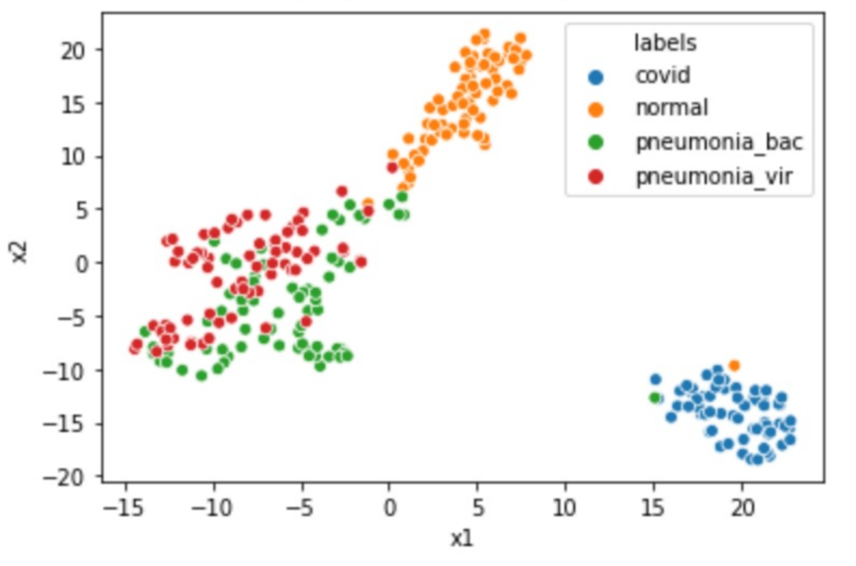

# Conclusion

Through the analysis above, we can conclude that ResNet50 is the preferred architecture for both binary and multi-class classification. We have successfully been able to train the neural network to classify Chest X-ray images in both tasks.